**Research on Assignment (System Analysis & Design)**

**Online Application & Student Management System**

Schools and Universities are the foundation of knowledge and an educational body on which students rely upon. Therefore, they need to maintain a proper database of its students to keep all the updated records and easily share information with students.

Most schools and Universities count on an advanced software tool commonly known as **'Student Information System (SIS)'** to keep all their student records and administrative operations including, examinations, attendance**,** and other activities.

Over the recent years, the performance and efficiency of the education industry have been enhanced by using the **Student Management System**. This tool has productively taken over the workload of the admin department with its well-**organized, easy, and reliable online school management software**.

SMS has proven to be well handling critical tasks such as:

* Admissions

The **SMS** software is created to help manage the student's admissions activities, starting from initial communication to course enrolment.

* Payments Of Fees

The Payments paid or received can also be managed and recorded through Student Management System

* Tracking Student’s Fees

The school administration department can track billing dates, induce late fee penalty, generate invoice, and automatically gets the report of received payments throughout the year.

**What should a Student Management System Include?**

* Student Schedule Management
* Grade Book and Transcript Information
* Student health information

**What to look for in a Student Management System?**

* A simple on boarding process
* A user- friendly interface
* Responsive design
* Cloud based

**Some pros and cons of Student Management System:**

**Pros:**

* **Better Management of Student Data**  
  A student management system is also a student [database management system](https://leadschool.in/how-best-school-management-software-makes-a-school-smart). It helps you manage all the student-related data in a well-organized manner.

A [Student Management System](https://leadschool.in/student-management-systems-a-saviour-for-kids-during-online-learning) gives you a unique ID against every student. And using that ID, you can easily track the fee status, assignments, exam results, grades, parent info within seconds.

* **Improves Overall Teacher Productivity**  
  Similar to the students, the teachers also become more productive with a student management system. It’s because, with a system in place, teachers won’t have to manually take attendance, manage timetables and assignments.
* Everything can be loaded on the [management software](https://leadschool.in/how-best-school-management-software-makes-a-school-smart), which can be accessed by all. This way, teachers can focus more on academics and learning than administrative tasks.
* **More environment friendly**

Trees do not have to be cut to make paper as everything is on a software databased.

**Cons:**

**I**n all fair words in depends on how the analysis, feasibility study and the design was conducted. And as a result of how it was done, it might be a bit costly.

**Online Application Management:**

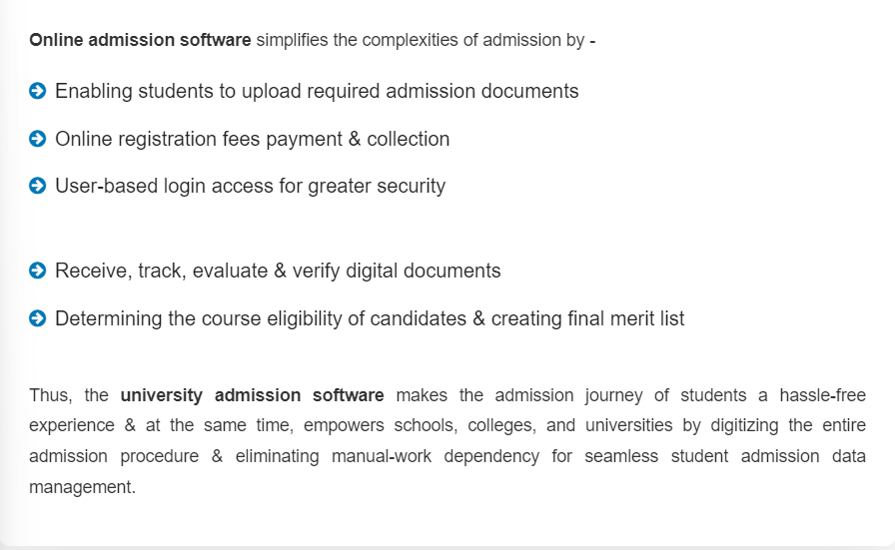

Some basic features of Online Admission System

Tasks performed by administrator

* 24×7 availability of application forms
* Password protected Pre registration process
* Online payment gateway integration .
* Student record management
* Publishing merit list of short listed candidates
* Eligibility Criteria

Tasks performed by applicants

* Registration as an applicant
* Upload /Update required documents
* Making payment via the portal